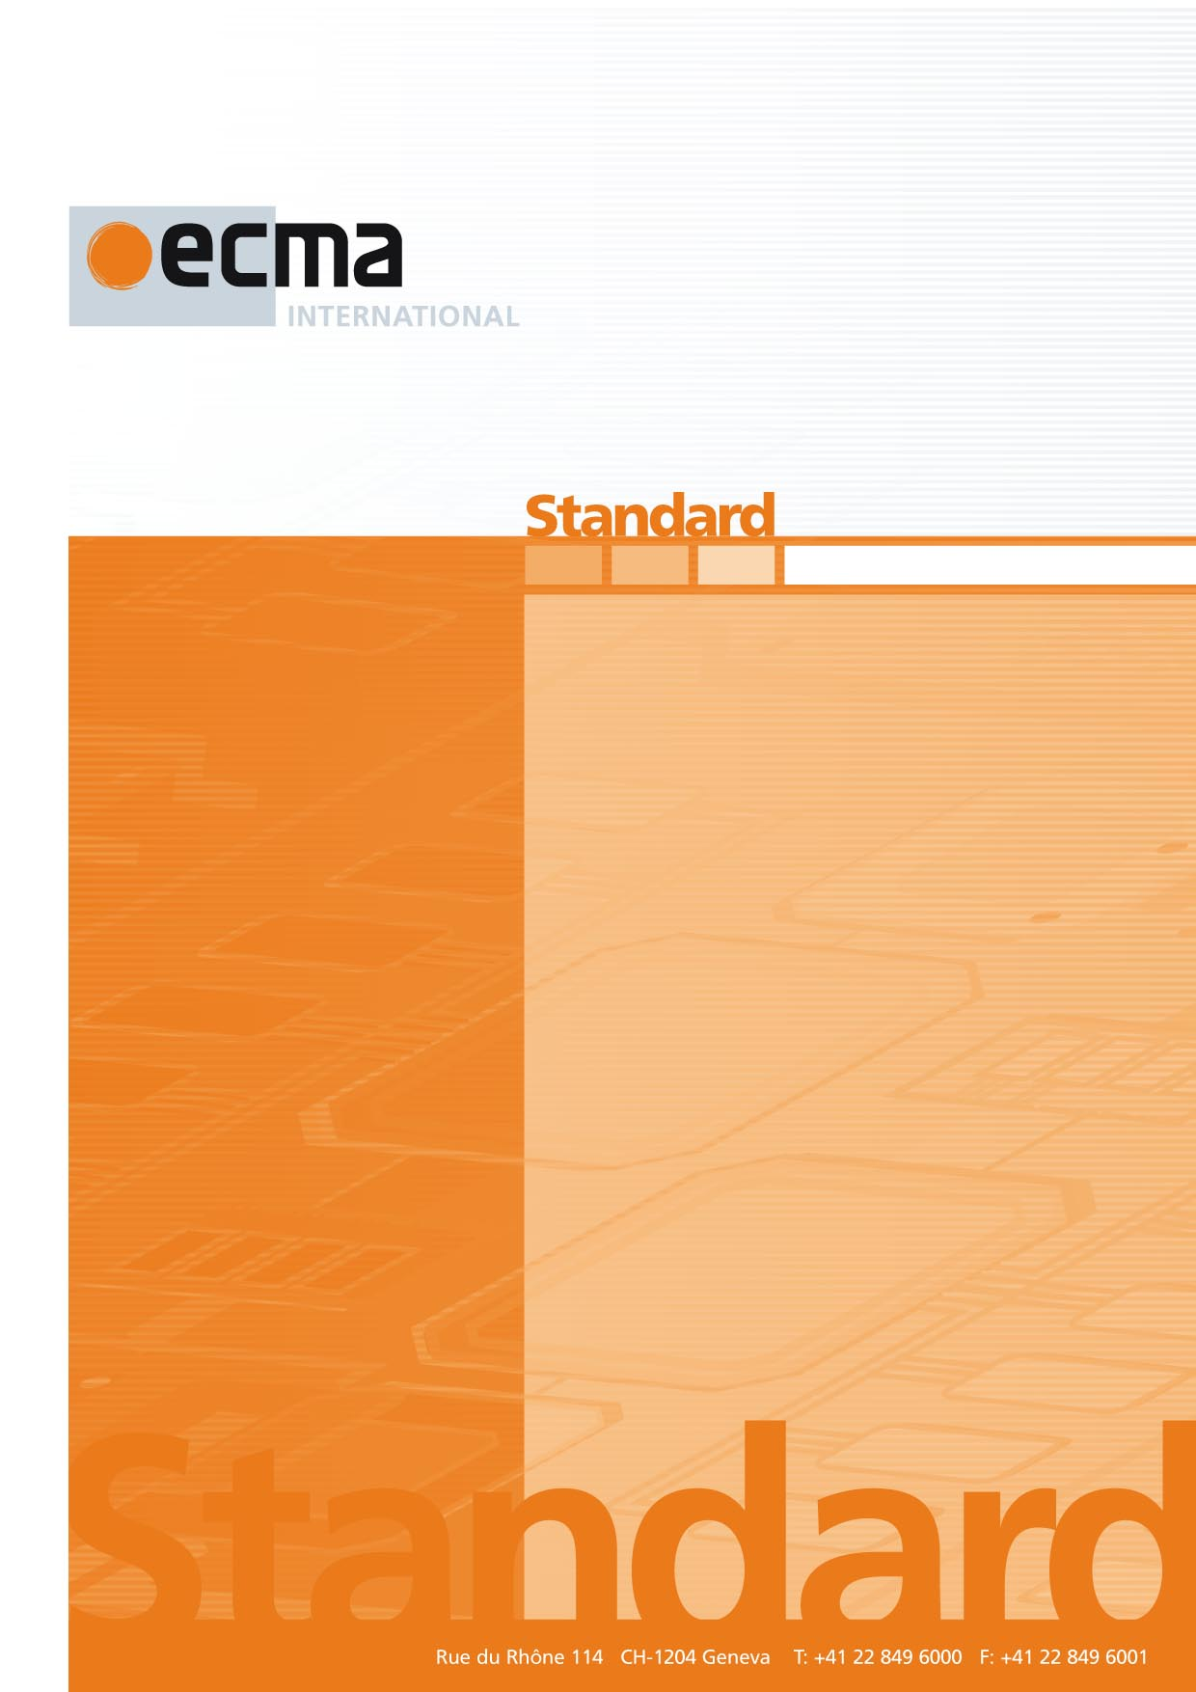

C# Specification Suite

ECMA-422

1st Edition / December 2022

Contents Page

1 Scope 1

2 Normative references 1

3 The C# language and library 1

3.1 C# language specification 1

3.2 C# library specification 1

Introduction

C# is a widely used, general-purpose programming language.

Essential components of a C# implementation are described in several individual standards, supplemented by a technical report. The C# Specification Suite is just a collection of those components, which are developed and maintained by Ecma International.

The Suite defined by this specification aggregates these components via normative and informative references to the latest published Ecma International specifications. This has the advantage that an update of the Suite is only needed if there is a change (addition or deletion) in the set of components.

This Ecma Standard was developed by Technical Committee 49 and was adopted by the General Assembly of December 2022.

*COPYRIGHT NOTICE*

*© 2022 Ecma International*

*This document may be copied, published and distributed to others, and certain derivative works of it may be prepared, copied, published, and distributed, in whole or in part, provided that the above copyright notice and this Copyright License and Disclaimer are included on all such copies and derivative works. The only derivative works that are permissible under this Copyright License and Disclaimer are:*

*(i) works which incorporate all or portion of this document for the purpose of providing commentary or explanation (such as an annotated version of the document),*

*(ii) works which incorporate all or portion of this document for the purpose of incorporating features that provide accessibility,*

*(iii) translations of this document into languages other than English and into different formats and*

*(iv) works by making use of this specification in standard conformant products by implementing (e.g. by copy and paste wholly or partly) the functionality therein.*

*However, the content of this document itself may not be modified in any way, including by removing the copyright notice or references to Ecma International, except as required to translate it into languages other than English or into a different format.*

*The official version of an Ecma International document is the English language version on the Ecma International website. In the event of discrepancies between a translated version and the official version, the official version shall govern.*

*The limited permissions granted above are perpetual and will not be revoked by Ecma International or its successors or assigns.*

*This document and the information contained herein is provided on an "AS IS" basis and ECMA INTERNATIONAL DISCLAIMS ALL WARRANTIES, EXPRESS OR IMPLIED, INCLUDING BUT NOT LIMITED TO ANY WARRANTY THAT THE USE OF THE INFORMATION HEREIN WILL NOT INFRINGE ANY OWNERSHIP RIGHTS OR ANY IMPLIED WARRANTIES OF MERCHANTABILITY OR FITNESS FOR A PARTICULAR PURPOSE.*

C# Specification SuiteINTERNATIONAL STANDARD© ISO/IEC 2008 – All rights reservedISO/IEC 10995:2008(E) 63Test method for the estimation of the archival lifetime of optical mediaInformation technology — Digitally recorded media for information interchange and storageTechnologies de l'information — Supports enregistrés numériquement pour l'échange et le stockage d'information — Méthode d'essai pour l'estimation de la durée de vie d'archivage des supports optiquesInformation technology — Digitally recorded media for information interchange and storage — Test method for the estimation of the archival lifetime of optical mediaE2008-02-22(60) PublicationISO/IECISO/IEC    International Standard 2008ISO/IEC 10995ISO/IEC 10995ISO/IEC 10995   Information technology  JTC1 2Heading 2Heading 1     0 CR6STD Version 2.260   4O:\Documents\JTC001\SC023\046554 - ISO_IEC CD 10995 (Ed 1)\60.00\310\046554e\C046554e.doc

# Scope

This specification defines the C# programming language and its required library. It defines all the necessary components that are needed to implement this Suite. This Suite does not change if one or more components are updated by a new standard edition. The Suite changes only when new components are added to it and/or existing components are removed from it.

# Normative references

The following documents are referred to in the text in such a way that some or all of their content constitutes requirements of this document. For dated references, only the edition cited applies. For undated references, the latest edition of the referenced document (including any amendments) applies.

ECMA-334, *C# language specification*, <https://www.ecma-international.org/publications-and-standards/standards/ecma-334/>

ECMA-335, *Common Language Infrastructure (CLI) : Partition IV: Profiles and Libraries*, <https://www.ecma-international.org/publications-and-standards/standards/ecma-335/>

# The C# language and library

An implementation of C# consists of the C# programming language and its required library, and shall conform to ECMA-334, and the relevant parts of ECMA-335: Partition IV, respectively.

The following Ecma Standards are part of the current C# Specification Suite:

* ECMA-334, *C# language specification*
* ECMA-335, *Common Language Infrastructure (CLI) : Partition IV: Profiles and Libraries*

## C# language specification

This component defines the syntax and semantics of the C# language and its pre-processing directives; optional features; and a library that shall be available for use by C# programs as they execute.

## C# library specification

This component defines the syntax and semantics of a family of types usable from a C# program. As published, ECMA-335 contains more facilities than are required by a C# implementation. The subset of facilities that are required by C# are specified in the normative annex “Standard library” of ECMA-334.

Bibliography

1. ECMA TR/84, *Common Language Infrastructure (CLI) - Information derived from Partition IV XML file*, <https://www.ecma-international.org/publications-and-standards/technical-reports/ecma-tr-84/>